IHPCP Goal Evaluation Worksheet
Date: July HPG Meeting Day 2 2024

Ending the HIV Epidemic Pillar: Prevent
Goal: Prevent new HIV transmissions by using proven interventions, including pre-exposure prophylaxis (PrEP) and syringe services programs (SSPs).
Strategy: Strategy 1A: Implement Data-to-Care (D2C) approaches to reengage People Living With HIV (PLWH) into care
Key Disparity Metric (s): testing and linkage outcomes by race, ethnicity, and SGM status
Data Sets Informing this Objective: Stakeholder Input Data # 11, 13; Epidemiological data

Priority Setting:
The HPG voted these as their top priorities
- SPBP/ADAP (collapsed because SPBP serves this purpose in PA) | - Emergency Financial Assistance
- Housing | - Health Insurance Premiums
- Medical Case Management | - Outreach Services
- Early Intervention Services | - Home and Community Based Care
- Outpatient/Ambulatory Care | - Oral Health Care

HPCP Activity(s):
# | Activity | Need/Gap/  Barrier & Priority Pop. | Responsible Party & Partnerships | Data Baseline | Target Goals/ Outcomes
1 | Identify persons with previously diagnosed HIV who are not in care. | Gap: All people living with HIV (PLWH) not in care/lost to care  Priority: black, Indigenous and People of Color (BIPOC) and Sexual & Gender Minorities (SGM) communities | Division  Partner: HIV Surveillance | An estimated 105 PLWH identified as not in care by nine providers | Implement Central Output Model to engage individuals statewide in D2C  Increase # identified as not in care to include entire state
2 | Provide linkage to, re-engagement in, and retention in HIV medical care services for persons with previously diagnosed HIV who are not in care. | Gap: All PLWH not in care/lost to care  Priority Pop: BIPOC and SGM communities | Division  Partner: HIV Surveillance | Number of PLWH linked to care, re-engaged and/or retained in care as a result of D2C | 25% increase in number of PLWH linked to care, reengaged and/or retained in care as a result of D2C
3 | Expand D2C process across the state to include all regional jurisdictions. | Gap: All PLWH not in care/lost to care  Priority Pop: BIPOC and SGM communities | Division; Partners: County Municipal Health Departments (CMHD) | 9 (# of 2021 D2C sites) | 10 CMHD and 6 Districts

Please describe the program as a whole.
- The Data-to-Care (D2C) Central Output Model uses a structured approach to identifying individuals living with HIV who are not currently engaged in care and facilitating their re-engagement through targeted interventions. HIV surveillance data from PA-NEDSS and eHARS, ART claims data from SPBP, and CAREWare data are merged to create a comprehensive list of Presumptively Not-in-Care (NIC) individuals. D2C coordinator sends this list to CMHD and Department field staff by jurisdiction every month. CMHD and Department field staff conduct re-engagement activities to ensure PLWH are in care and document their efforts in PA-NEDDSS. D2C coordinator reviews the follow-up activities for completeness and accuracy. A public health strategy to identify individuals living with HIV who are out of care and engage them back in medical care.
- Engagement in HIV medical care is essential to achieve viral suppression.

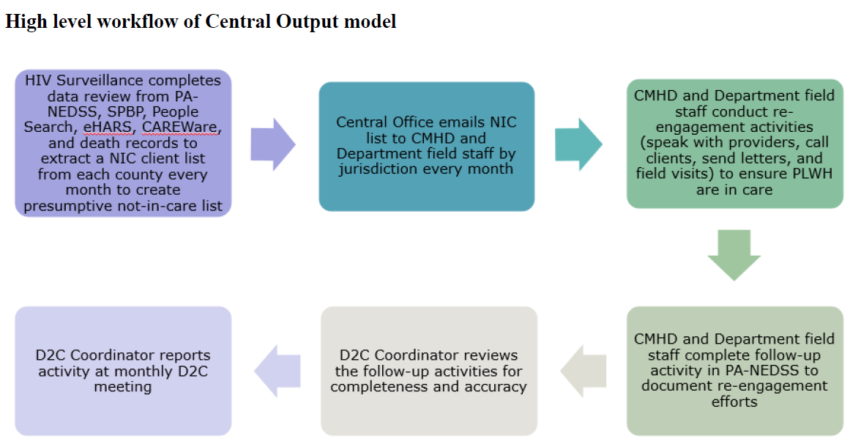

Describe the data indicators (if applicable) listed for your strategy and activity in the IHPCP.
Are there state or national standards?
We follow all the national standards and have enforced state standards. We utilize various care markers from HIV Surveillance and supplemented by Care Ware and SPBP data sets. Care markers obtained include HIV 4th Gen, HIV Primary Care, HIV Risk Counseling (Chronic Illness), HIV Risk Reduction Counseling, iART follow ups, RNA-PCR, HIV GENOTYPE and HIV TYPE-DIFFERENTIATION.

What are your baseline data and your current data indicators?

Disposition Status | Cases
Already in Care | 430
Deceased | 50
Not in Care | 46
Linked to Care | 44
Out of Jurisdiction (OOJ) | 34
Central Output- OOJ | 59
Unable to Determine | 61
Not Dispositioned | 54
New Labs | 69
Total | 847

Current Data Indicators:
- D2C NIC Identification: Percentage of presumptively not-in-care PWH with an investigation opened (initiated) during a specified 6-month evaluation time period, who were confirmed within 90 days after the investigation was opened not to be in care.
Among these cases, 67.40% were confirmed within 90 days of investigation initiation to indeed not be in care.
- D2C NIC Linkage: Percentage of PWH confirmed during a specified 6-month evaluation time period not to be in care, who were linked to HIV medical care within 30 days after being confirmed not to be in care.
This figure was determined to be 67%.
- D2C NIC Viral Suppression: Percentage of PWH linked to HIV medical care during a specified 6-month evaluation time period, who achieved HIV viral suppression within six months (180 days) after being linked to care.
This figure, representing the number of individuals achieving viral suppression, was calculated to be 9.10%."

Decreased | 3
Got suppressed | 4
Increased | 5
No labs | 8
No VL | 5
Suppressed | 19
Grand Total | 44

What groups(s) are your target population(s) and how was that decided?
Does your target population(s) align with the disparity metrics outlined in the IHPCP under the corresponding strategy?

Target Population:
- Individuals living in PA (excluding Philadelphia) with care marker prior to 12-month time-period.
Decision on Target Populations:
- The focused populations are determined based on surveillance data that identify gaps in the HIV care continuum. This data likely includes information on HIV diagnoses, linkage to care, retention in care, and viral suppression rates.
- Surveillance data is used to create lists of individuals in need of follow-up. This approach ensures that resources are focused towards those who are most at risk of falling out of or not engaging in HIV care.
Alignment with Disparity Metrics in IHPCP:
- The IHPCP typically outlines specific disparity metrics related to HIV prevention and care, focusing on populations that experience higher rates of HIV incidence and poorer outcomes due to social determinants of health.
- The focused populations identified (NIC, non-virally suppressed in care) are likely aligned with these disparity metrics by addressing gaps in care and outcomes among vulnerable groups.

How are you measuring your success in accomplishing or maintaining this activity?
We are looking at the number of linked to care individuals and those that are virally suppressed. We also monitor field staff’s success in conducting ORR.

What barriers or challenges have you experienced/are experiencing?
- Transitioning from provider model to COM.
- The first COM NIC list was much larger than anticipated, there were a few jurisdictions unable to complete re-engagement activities within the requested 30-days.
- Significant staff changes affected generating an accurate NIC list as systems weren’t updated in a timely manner.
- The Lexis Nexis searches, and consequent updates to PA-NEDSS, and email distribution of NIC lists are still done manually by the HPP and HSP D2C coordinators. People search software is not as accurate and up-to-date as expected.
- Issues were identified regarding provider CD4 and viral load reporting. This led to a delay in a few counties.
- Accurate information on whether individuals are in care and following-up with physician can be hard to obtain.

What solutions to these barriers and challenges have you come up with?
- The field staff were given 60-days to complete the first COM NIC list. Additionally, the number of cases have been significantly less as compared to the initial list.
- We are working with BIIT to automate the monthly NIC emailing process and send a reminder to field staff on bi-weekly basis. We are hoping this will be completed by the fall ’24.
- Central Output was rolled out statewide to reach out to larger number of PLWH who are lost to care.
- Field Staff training on Central Output model, expectations for Outreach and re-engagement, and documentation of activity.
- PA-NEDSS updated with D2C follow-up activity to streamline the process.
- Protocol prepared on the new model and included in Field Staff manual as a resource guide.
- The issue regarding provider reporting was resolved and lab results were updated on NEDSS.

If you had to give a percentage of how close you are to completing this goal(s), what would it be and why?

Implementation of the Central Output Model of D2C has been fully operational for approximately 18 months.
Field Staff Supervisors will be trained for a second level of monitoring in August (ensure completeness of D2C).
Working on automating more of the communication between Central Office and Field Staff – 50% complete
What are your next steps? What is the sustainability of this effort (if applicable)?
Continue to do D2C with consistent QA activities to improve NIC list
Automate communication of initial NIC list
Automate “people search” step (ensuring accurate contact information for individuals on NIC list)
Is there anything additional you’d like the HPG Evaluation Subcommittee to know?

Are there any other individuals associated with the program you’d like to recognize?
Krupali Patel, Data Analyst with Surveillance

This section is for Evaluation Subcommittee purposes only

